CITY OF BELMONT
Facilities for Hire

Forster Park Community Centre & Reserve

Forster Park Community Centre is conveniently located close to both Leach & Tonkin Highway and features the City’s largest capacity hall, ideal for large functions such as weddings and birthdays. The center also has a large multi-purpose room that is primarily used by sporting clubs. Forster Park Community Centre is adjacent to a sporting reserve that is primarily used for tee-ball and baseball during summer and football during winter.
GENERAL INFORMATION
Address | 130 Keane Street, Cloverdale (Corner of Keane Street & Abernethy Road)
Access Friendly | Yes, access friendly parking, ramps and toilets available
CCTV | Yes (cameras will not be turned off for bookings and are not permitted to be obstructed at any time)
Parking | Yes – 91 main carpark bays and bays along Keane Street
Wi-Fi | No
Equipment | Items such as TV’s, projectors, audio/visual equipment and also cleaning equipment etc. are not provided and not available for hire through the City. Hirers have to supply all their own required equipment.
ROOMS AVAILABLE FOR HIRE

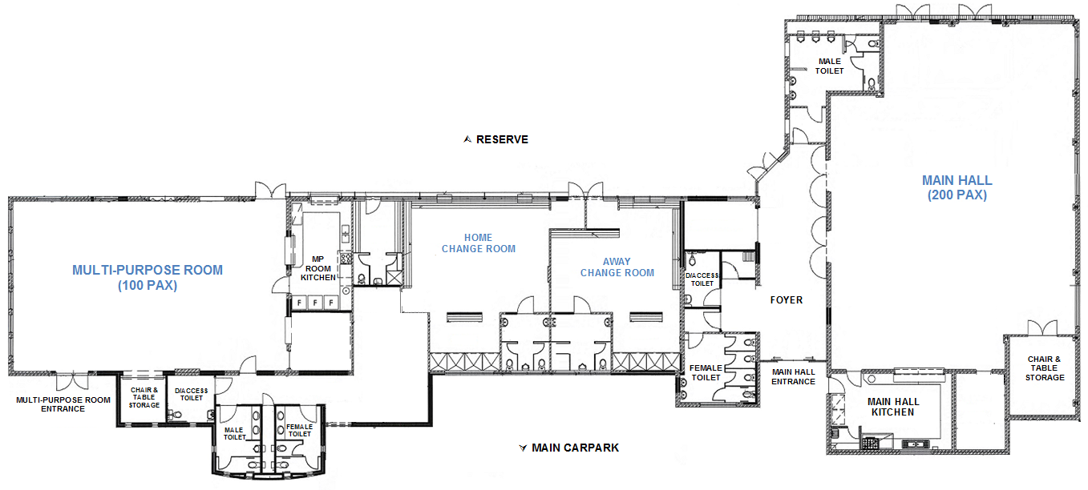

MAIN HALL
​Size |  | ​Approximately 14m x 15m (210sqm)
​Max Capacity |  | ​200 people (It is an offence under Health Act 1911 to exceed the maximum capacity stipulated on the certificate of approval)
​Floor |  | ​Timber, Carpet Surrounds
​Chairs |  | ​200 (measurements and photos available upon request)
​Tables |  | ​25 trestle tables - 1800mm x 750mm (photos available upon request)
​Air Conditioning |  | ​Evaporative (cooling only)
​Kitchen |  | Yes, included in hire is a large kitchen with a fridge/freezer, large gas stove and electric oven, auto boiler urn, microwave and servery to hall. Hirers are required to bring all their own plates/cutlery/cookware/cleaning equipment. The kitchen is to be used for warming up food purposes only.
Toilets |  | Yes – the hall has its own toilet facilities in the foyer area.
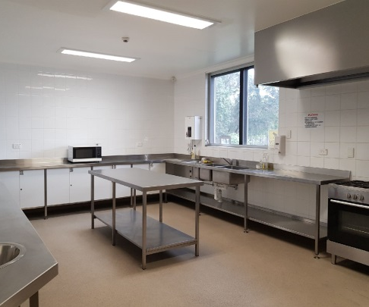
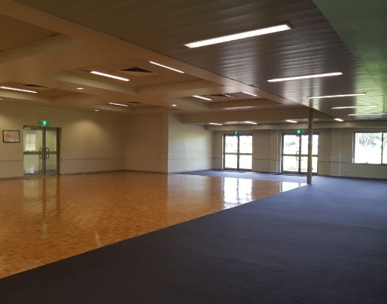
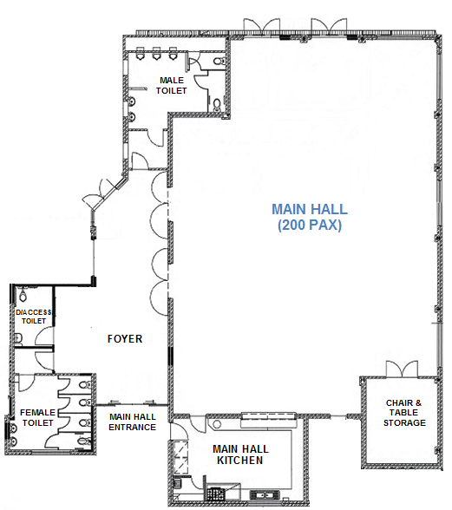

Areas Inc. in Hire
Main Hall Kitchen
Main Hall

MULTI-PURPOSE ROOM
Size | Approximately 9m x 14.5m (130sqm)
​Max Capacity | ​100 people (It is an offence under Health Act 1911 to exceed the maximum capacity stipulated on the certificate of approval)
​Floor | ​Vinyl
​Chairs | ​100 (measurements and photos available upon request)
​Tables | 10 trestle tables - 1800mm x 750mm (photos available upon request)
​Air Conditioning | ​Evaporative (cooling only)
​Kitchen | ​Yes, included in hire is a Fridge/freezer, small stove and oven, auto boiler urn, microwave and servery into room. Hirers are required to bring all their own plates/cutlery/cookware/cleaning equipment. The kitchen is to be used for warming up food purposes only.
Toilets | Yes – this room has its own toilet facilities located in the passageway.
Note | - The TV in this room is for club use only.  - The kiosk roller door that serves outside is not available to casual hirers.
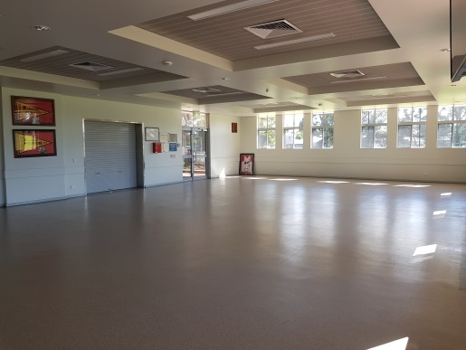
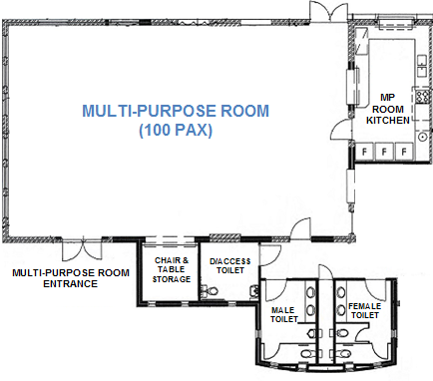
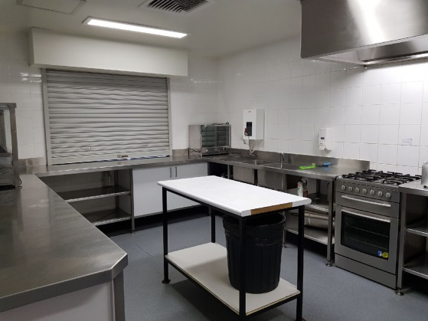
Areas Included in Hire (toilets & foyer shared use)
Areas Included in Hire (toilets & foyer shared use)
Areas Included in Hire (toilets & foyer shared use)
Areas Included in Hire (toilets & foyer shared use)
Hall
Hall
Hall

Areas Inc. in Hire
Multi-Purpose Room
Multi-Purpose Room Kitchen
RESERVE
Sport Hire  (fees applicable) | WINTER: Football (AFL) – Line markings and goals in place 1 April – 30 Sept  SUMMER: Tee-Ball & Baseball - Line markings and dugouts in place 1 Oct – 30 March
Parking | Parking is available in the centre carpark, parallel bays on Keane Street & verge parking permitted on Fisher Street
Toilets | There is a public toilet block along Fisher Street – unlocked during day light hours.
Oval Lighting | There are three light towers available for hire – fees are applicable and suitable for large ball sport training only.
Changerooms | Yes – available for hire with reserve (toilets/showers)
Additional | A free to use playground and half-court basketball court are located on the reserve near the corner of Scott Street & Fisher Street.

KEANE STREET

PUBLIC TOILETS
VERGE PARKING (Fisher Street)
STREET PARKING (along Keane St)

TEE-BALL/BASEBALL
(during summer)

FISHER STREET

MULTI-PURPOSE ROOM

FOOTY GOALS & MARKINGS (during winter)
PLAYGROUND & BASKETBALL COURT
CHANGE ROOMS
MAIN CAR PARK
(Off Keane Street)

MAIN HALL

TEE-BALL/BASEBALL
(during summer)
SCOTT STREET
ABERNETHY ROAD

Video tours of this facility are available on the City’s website
http://www.belmont.wa.gov.au/Community/VenuesForHire

For further information and availability please contact venue.hire@belmont.wa.gov.au

