CITY OF BELMONT
Facilities for Hire

Rivervale Community Centre

Rivervale Community Centre features a large main hall, ideal for weddings, dance classes and large social functions. Meeting Room 2/3 is recommended for smaller family functions such as children’s parties due to the room having an enclosed play area attached. This centre also features a small meeting room.
GENERAL INFORMATION
Address | 100 Gerring Court, Rivervale (corner of Surrey Road & Francisco Street)
Access Friendly | Yes, access friendly parking and toilets available
CCTV | Yes (cameras will not be turned off for bookings and are not permitted to be obstructed at any time)
Parking | Small carpark on Francisco Street (14 bays) & street parking on Gerring Ct & Surrey Rd
Wi-Fi | No
Equipment | Items such as TV’s, projectors, audio/visual equipment and also cleaning equipment etc. are not provided and not available for hire through the City. Hirers have to supply all their own required equipment.
Alcohol Use | Alcohol consumption is not permitted at this centre Monday to Friday before 6pm.  (An Application to Consume Liquor is required to be submitted for all other proposed times)
ROOMS AVAILABLE FOR HIRE

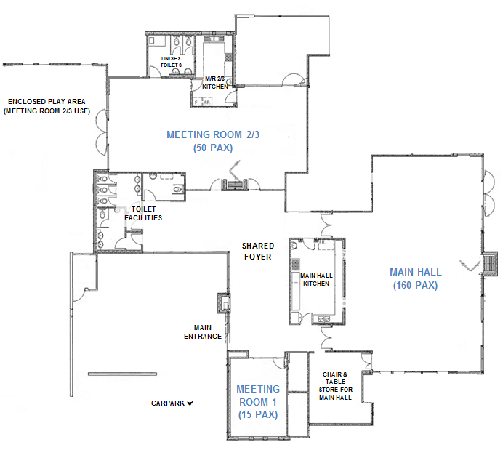
OUTDOOR AREA
(MEETING ROOM 2/3 USE)

MAIN HALL
​Size |  | ​Approximately 16.5m x 11m (181sqm)
​Max Capacity |  | ​160 people (It is an offence under the Health Act 1911 to exceed the maximum capacity stipulated on the certificate of approval)
​Floor |  | ​Timber
​Chairs |  | ​160 (measurements and photos available upon request)
​Tables |  | ​25 trestle tables - 1800mm x 750mm (photos available upon request)
​Air Conditioning |  | ​Evaporative (cooling only)
​Kitchen |  | Yes, included in hire is a large kitchen with a fridge/freezer, large gas stove and electric oven, auto boiler urn, microwave and serveries into the hall. Hirers are required to bring all their own plates/cutlery/cookware/cleaning equipment. The kitchen is to be used for warming up food purposes only.
Toilets |  | Yes - shared facilities with the other rooms in the centre (located in foyer)
Additional |  | This hall features a divider that can separate the hall into two sections
access
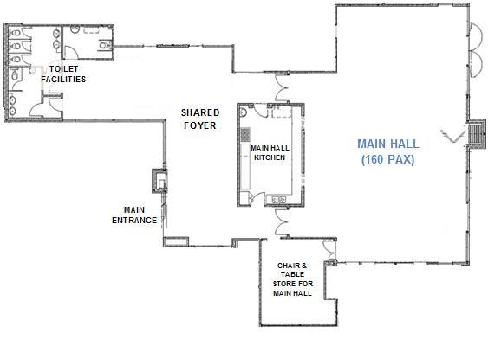
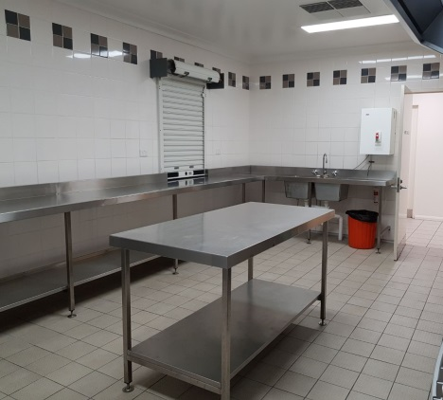
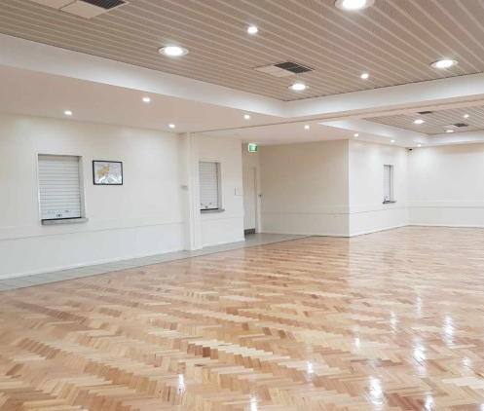

Hall (view of stage area)

Main Hall Kitchen
Main Hall
Areas Included in Hire (toilets and foyer shared use)

​MEETING ROOM 1
Size | Approximately 27sqm
​Max Capacity | ​15 people (It is an offence under the Health Act 1911 to exceed the maximum capacity stipulated on the certificate of approval)
​Floor | ​Vinyl
​Chairs | ​15 (measurements and photos available upon request)
​Tables | 3 trestle tables - 1800mm x 750mm (photos available upon request)
​Air Conditioning | ​Split System (heating & cooling)
​Kitchen | ​None included
Toilets | Yes - shared facilities with the other rooms in the centre (located in foyer)
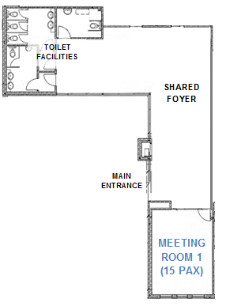
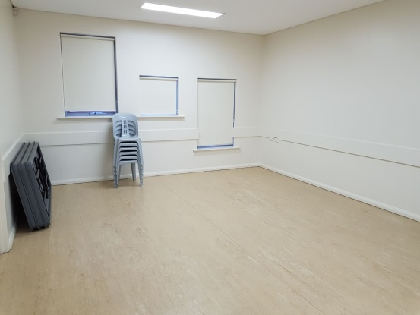
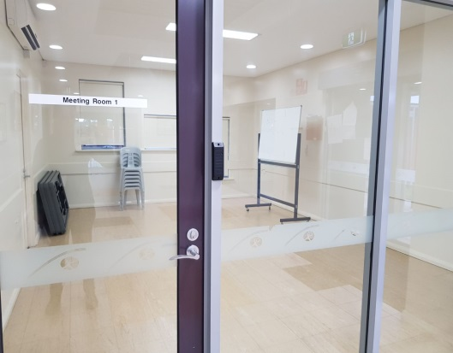

Meeting Room 1
Areas Included in Hire
(toilets and foyer shared use)
Meeting Room 1
Meeting Room 1

​MEETING ROOMS 2/3
Size | Approximately 7m x 10m (70sqm)
​Max Capacity | ​50 people (It is an offence under the Health Act 1911 to exceed the maximum capacity stipulated on the certificate of approval)
​Floor | ​Vinyl
​Chairs | ​50 (measurements and photos available upon request)
​Tables | 7 trestle tables - 1800mm x 750mm (photos available upon request)
​Air Conditioning | ​Evaporative (cooling only)
​Kitchen | ​Yes, included in hire is a kitchen with a fridge/freezer, oven, auto boiler urn and microwave. Hirers are required to bring all their own plates/cutlery/cookware/cleaning equipment. The kitchen is to be used for warming up food purposes only.
Toilets | There are unisex facilities inside the room however the main facilities are- shared with the Hall & Meeting Rooms (located in foyer).
Additional | - Large enclosed play area (slide, sandpit etc.) under a shade sail.  - A second enclosed courtyard is attached to the room overlooking the park area.  - This room features a divider that can split the room into two sections.  - Pin boards available for use during the time of hire.
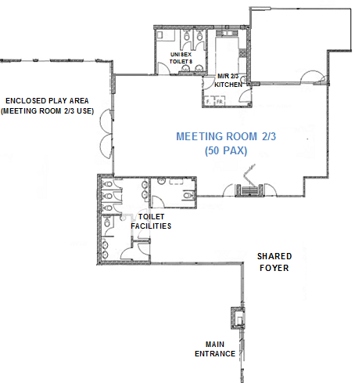
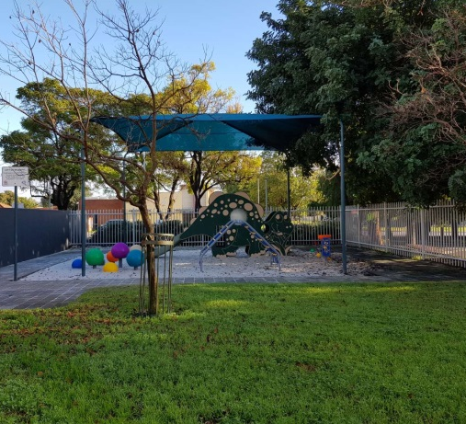
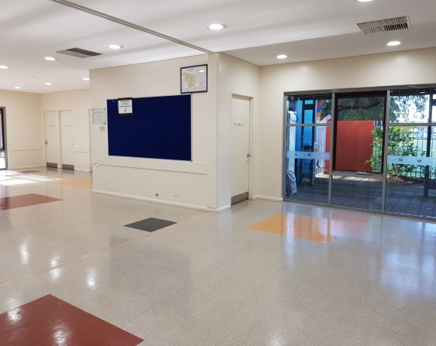
OUTDOOR AREA
(MEETING ROOM 2/3
USE)
Multi-Purpose Room
Multi-Purpose Room

Areas Included in Hire
(toilets and foyer shared use)
Meeting Room 2/3
Meeting Room 2/3 Play Area

Video tours of this facility are available on the City’s website
http://www.belmont.wa.gov.au/Community/VenuesForHire

For further information and availability please contact venue.hire@belmont.wa.gov.au

