CITY OF BELMONT

**Facilities for Hire**

**Centenary Park Community Centre & Reserve**

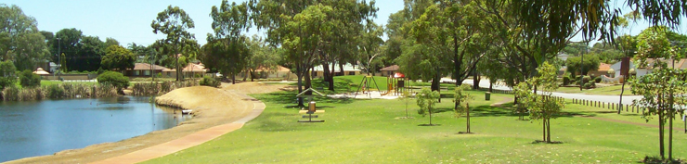

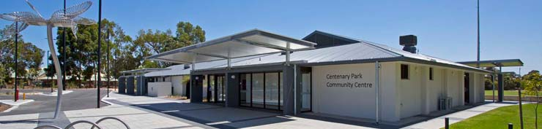

Rollup Image

Long Description

Centenary Park Community Centre is located close to Great Eastern Highway and features a large main hall, ideal for large functions and dance classes, a multi-purpose room primarily used by sporting clubs and a lesser hall that is ideal for playgrounds and smaller functions. The centre also contains a small meeting room. It is adjacent to a sporting reserve that is primarily used for cricket and rugby. There is a large lake area with multiple gazebos for picnics and barbeques.

|  |  |
| --- | --- |
| **GENERAL INFORMATION** | |
| Address | 105 Daly Street, Belmont (Corner of Daly Street & Barker Street) |
| Access Friendly | Yes, access friendly parking, ramps and toilets available |
| CCTV | Yes *(cameras will not**be turned off for bookings and are not permitted to be obstructed at any time)* |
| Parking | Yes – 52 carpark bays plus street parking |
| Wi-Fi | No |
| Equipment | Items such as TV’s, projectors, audio/visual equipment and also cleaning equipment etc. are not provided and not available for hire through the City. Hirers have to supply all their own required equipment. |
| **ROOMS AVAILABLE FOR HIRE** | |
|  | |

|  |  |
| --- | --- |
| **MAIN HALL** | |
| ​Size | ​Approximately 12m x 13m (156sqm) |
| ​Max Capacity | ​150 people (*It is an offence under Health Act 1911 to exceed the maximum capacity stipulated on the certificate of approval)* |
| ​Floor | ​Timber |
| ​Chairs | ​150 *(measurements and photos available upon request)* |
| ​Tables | ​20 trestle tables - 1800mm x 750mm *(photos available upon request)* |
| ​Air Conditioning | ​Evaporative *(cooling only)* |
| ​Kitchen | Yes, included in hire is a large kitchen with a fridge/freezer, large gas stove and electric oven, auto boiler urn, microwave and servery to hall. Hirers are required to bring all their own plates/cutlery/cookware/cleaning equipment. The kitchen is to be used for warming up food purposes only. |
| Toilets | Yes – shared facilities with the Lesser Hall & Meeting Room (located in foyer) |

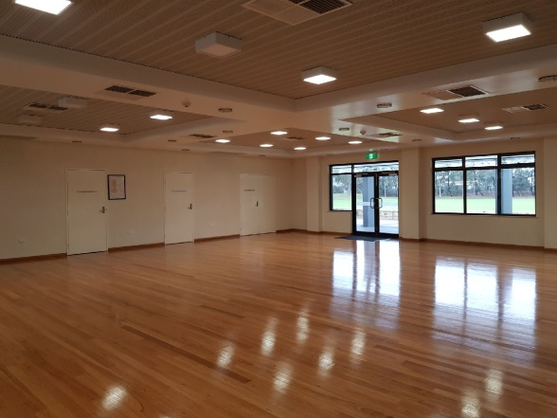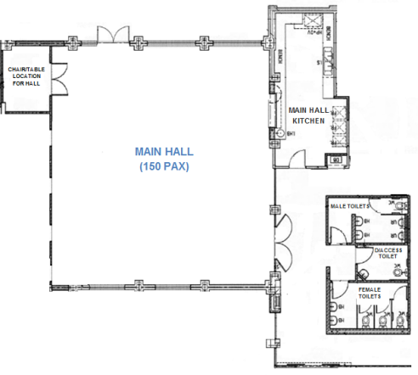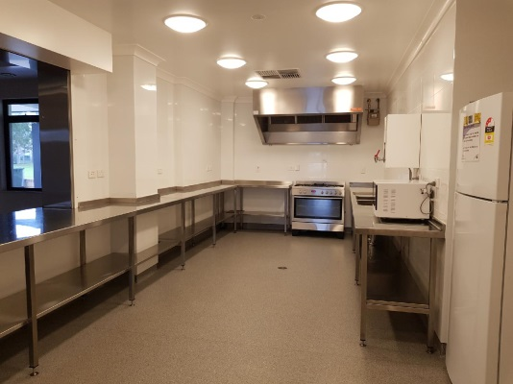

Areas Included in Hire   
*(toilets & foyer shared use)*

Main Hall

Main Hall Kitchen

Hall

Hall Kitchen

|  |  |
| --- | --- |
| ​**MULTI-PURPOSE ROOM** | |
| Size | Approximately 6.5m x 10.5m (68sqm) |
| ​Max Capacity | ​70 people (*It is an offence under Health Act 1911 to exceed the maximum capacity stipulated on the certificate of approval)* |
| ​Floor | ​Vinyl |
| ​Chairs | ​70 *(measurements and photos available upon request)* |
| ​Tables | 10 trestle tables - 1800mm x 750mm *(photos available upon request)* |
| ​Air Conditioning | ​Evaporative *(cooling only)* |
| ​Kitchen | ​Yes, included in hire is a fridge/freezer, small stove and oven, auto boiler urn and microwave. Hirers are required to bring all their own plates/cutlery/cookware/cleaning equipment. The kitchen is to be used for warming up food purposes only. |
| Toilets | Yes – this room has its own facilities (located in passageway, adjacent to change rooms) |
| Additional | Pin board available for use during hire |
| Note | The kiosk roller door that serves outside is not available to casual hirers |

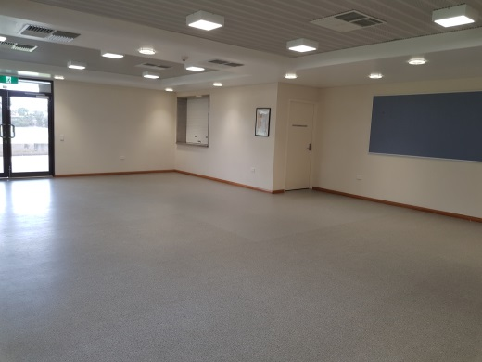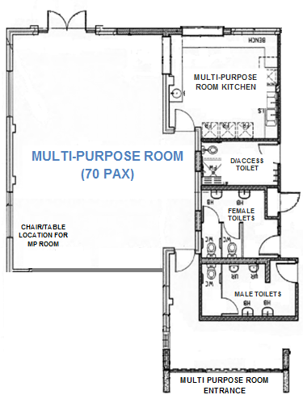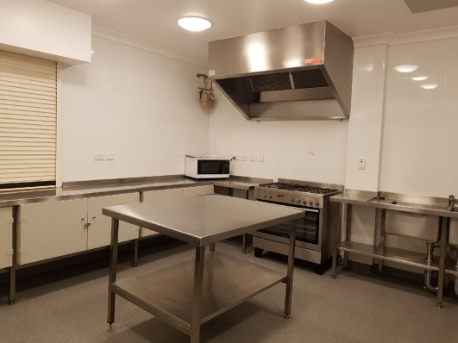

Multi-Purpose Room

Areas Included in Hire

Multi-Purpose Room Kitchen

Multi-Purpose Room

Multi-Purpose Room Kitchen

|  |  |
| --- | --- |
| ​**LESSER HALL** | |
| Size | Approximately 7.5m x 10m (75sqm) |
| ​Max Capacity | ​50 people (*It is an offence under Health Act 1911 to exceed the maximum capacity stipulated on the certificate of approval)* |
| ​Floor | ​Vinyl |
| ​Chairs | ​50 *(measurements and photos available upon request)* |
| ​Tables | 7 trestle tables - 1800mm x 750mm *(photos available upon request)* |
| ​Air Conditioning | ​Evaporative *(cooling only)* |
| ​Kitchen | ​Yes, included in hire is a small fridge/freezer, auto boiler urn and microwave. Hirers are required to bring all their own plates/cutlery/cookware/cleaning equipment.The kitchen is to be used for warming up food purposes only. The cupboards are locked and not available for casual hirers. |
| Toilets | Yes – shared facilities with the Main Hall & Meeting Room (located in foyer) |
| Additional | Pin board available for use during hire |

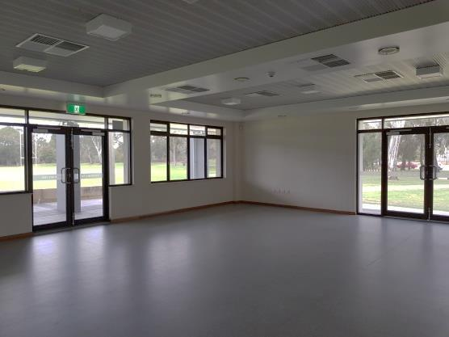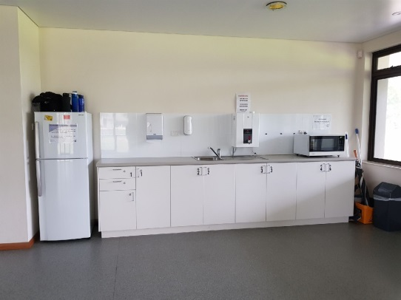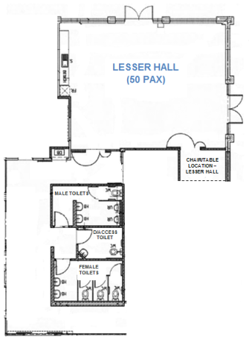

Areas Included in Hire   
*(toilets and foyer shared use)*

Lesser Hall

Lesser Hall Kitchen

|  |  |
| --- | --- |
| ​**MEETING ROOM** | |
| Size | Approximately 3.5m x 4.4m (15sqm) |
| ​Max Capacity | ​15 people (*It is an offence under Health Act 1911 to exceed the maximum capacity stipulated on the certificate of approval)* |
| ​Floor | ​Carpet |
| ​Chairs | ​15 *(measurements and photos available upon request)* |
| ​Tables | 3 trestle tables - 1800mm x 750mm *(photos available upon request)* |
| ​Air Conditioning | ​Split System *(cooling and heating)* |
| ​Kitchen | ​None included |
| Toilets | Yes – shared facilities with the Main Hall & Lesser Hall (located in foyer) |

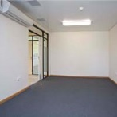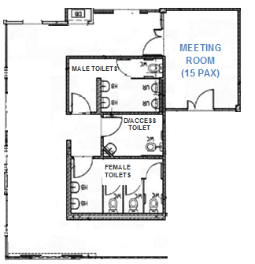

Areas Included in Hire   
*(toilets and foyer shared use)*

Meeting Room

|  |  |
| --- | --- |
| **RESERVE** | |
| Sport Hire *(fees applicable)* | WINTER: Rugby – Line markings and goals in place 1 April – 30 Sept  SUMMER: Cricket – Line markings and pitch in place 1 Oct – 30 March |
| Parking | Parking is available in the centre carpark and in the bays provided along Daly Street. |
| Toilets | There is an auto toilet located near the cricket practice nets – open during daylight hours. |
| Oval Lighting | There are two light towers available for hire – fees apply and suitable for large ball sport training only. |
| Changerooms | Yes – available for hire with reserve (toilets/showers) |
| Additional *(free to use)* | * Cricket practice nets available all year round * Outdoor exercise equipment * Playground located near Elmsfield Street |

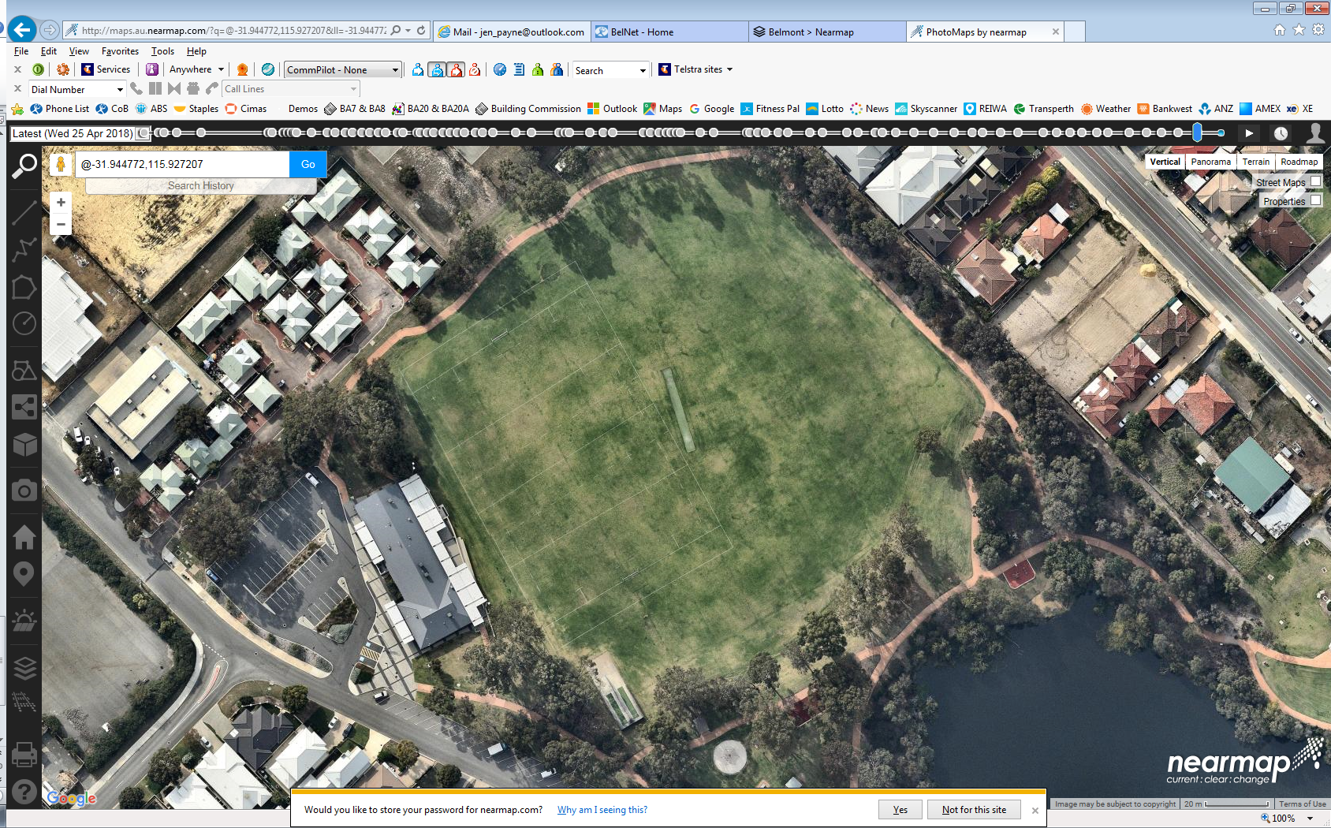

RUGBY GOALS & MARKINGS   
(during winter)

CRICKET PITCH   
(during summer)

MULTI-PURPOSE ROOM   
*(during summer)*

MAIN CARPARK (Daly Street)

CHANGE ROOMS   
*(during summer)*

MAIN HALL   
*(during summer)*

LESSER HALL   
*(during summer)*

CRICKET PRACTICE NETS

MEETING ROOM   
*(during summer)*

AUTO TOILET

STREET PARKING (Daly Street)

**DALY ST**

Video tours of this facility are available on the City’s website

<http://www.belmont.wa.gov.au/Community/VenuesForHire>

For further information and availability please contact [venue.hire@belmont.wa.gov.au](mailto:venue.hire@belmont.wa.gov.au)