CITY OF BELMONT

**Facilities for Hire**

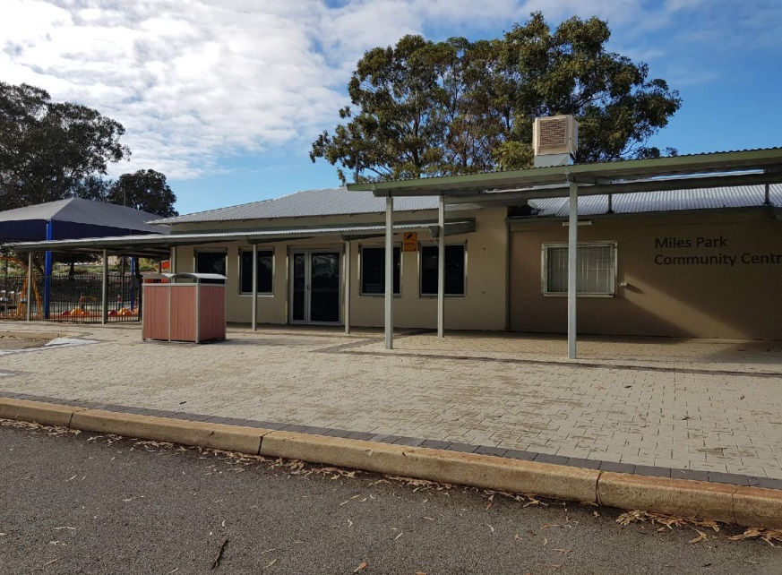**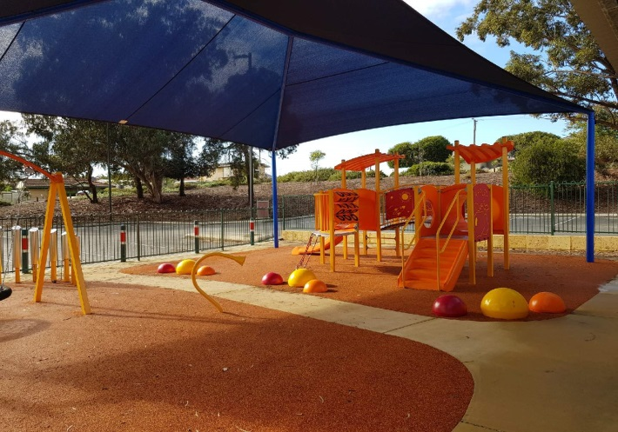Miles Park Community Centre & Reserve**

Rollup Image

Long Description

PeetMiles Park Community Centre features a large multi-purpose room and reserve. While the multi-purpose room is primarily used by sporting clubs, it also available to hire for small functions and having a playground attached, it is ideal for children’s birthday parties. It is adjacent to a sporting reserve that is used for soccer during winter.

|  |  |  |
| --- | --- | --- |
| **GENERAL INFORMATION** | | |
| Address | 289 Belgravia Street, Cloverdale (carpark off Lowes Street) | |
| Access Friendly | Yes, access friendly parking, ramps and toilets available | |
| CCTV | Yes *(cameras will not**be turned off for bookings and are not permitted to be obstructed at any time)* | |
| Parking | Yes – 90+ carpark bays off Lowes Street | |
| Wi-Fi | No | |
| Equipment | Items such as TV’s, projectors, audio/visual equipment and also cleaning equipment etc. are not provided and not available for hire through the City. Hirers have to supply all their own required equipment. | |
| **MULTI-PURPOSE ROOM** | | |
| ​Size | | ​Approximately 10m x 7m (70sqm) |
| ​Max Capacity | | ​50 people (*It is an offence under Health Act 1911 to exceed the maximum capacity stipulated on the certificate of approval)* |
| ​Floor | | ​Vinyl |
| ​Chairs | | ​50 *(measurements and photos available upon request)* |
| ​Tables | | ​6 trestle tables - 1800mm x 750mm *(photos available upon request)* |
| ​Air Conditioning | | Split System *(cooling and heating)* |
| ​Kitchen | | Yes, included in hire is a kitchen with a fridge/freezer, stove and oven, auto boiler urn, microwave and servery to room. Hirers are required to bring all their own plates/cutlery/cookware/cleaning equipment. The kitchen is to be used for warming up food purposes only. The kiosk roller door that serves outside is not available to hirers. |
| Toilets | | Yes – this room has its own facilities (located in the passageway) |
| Additional | | * There is a small enclosed play area under a shade sail. * There are pin boards available to use during the time of hire. |

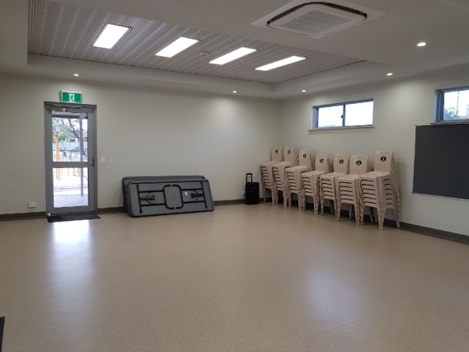

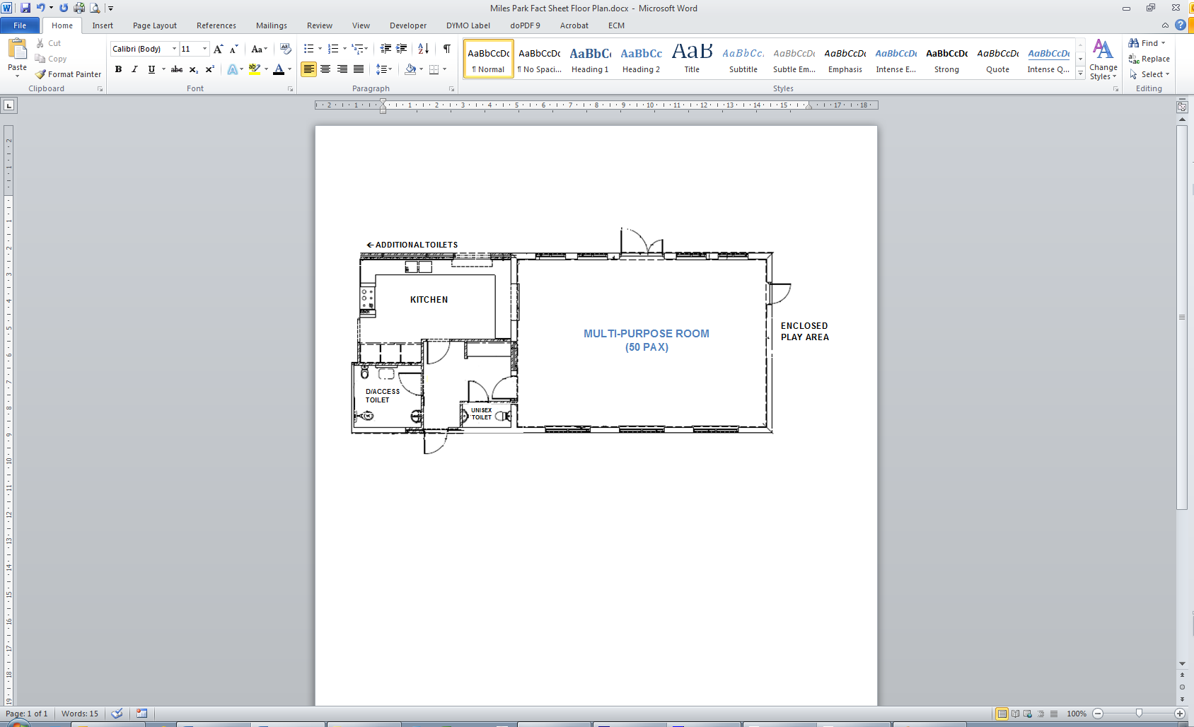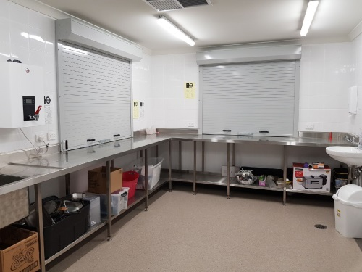

Multi-Purpose Room Kitchen

Lesser Hall Kitchen

Lesser Hall

Multi-Purpose Room

Areas Included in Hire

Kitchen

|  |  |
| --- | --- |
| **RESERVE** | |
| Sport Hire *(fees applicable)* | WINTER: Soccer – Line markings and goals in place 1 April – 30 Sept |
| Parking | Parking is available in the centre carpark. |
| Toilets | There are no public toilets available – toilets are available for use with hire of the reserve |
| Oval Lighting | There are multiple light towers on this reserve for hire – fees are applicable and suitable for large ball sport only. |
| Changerooms | Yes – available for hire with reserve (toilets/showers). |
| Additional *(free to use)* | There is a small basketball court and playground near the change rooms for use. |

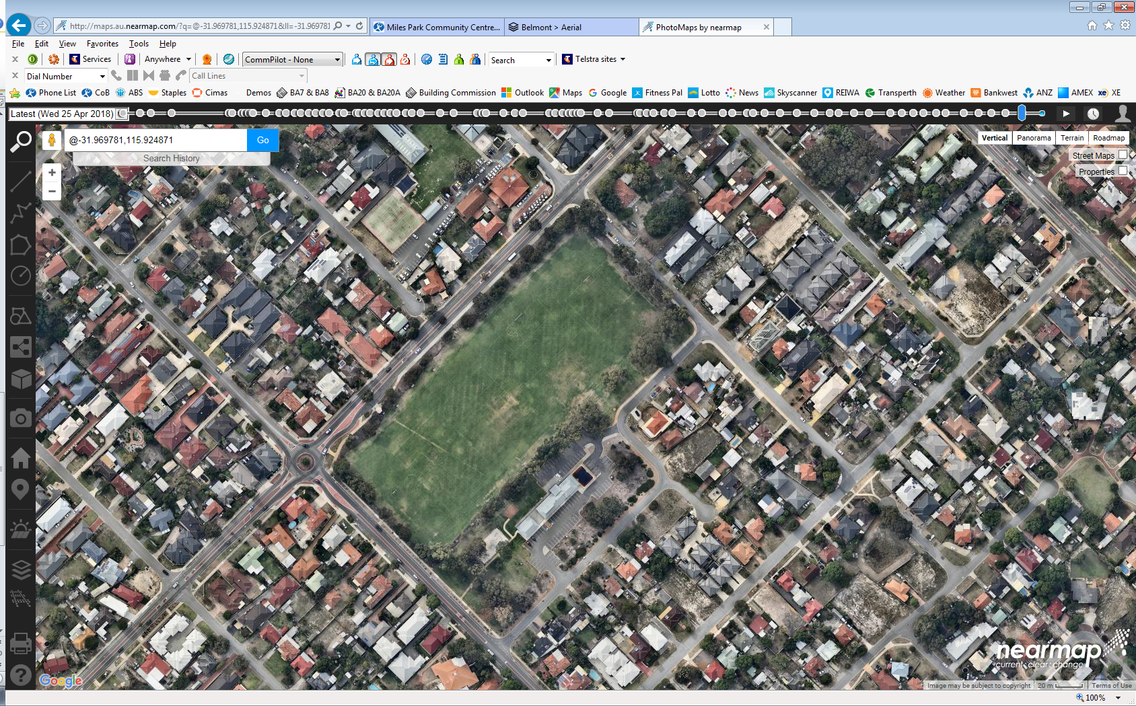

**WRIGHT STREET**

SOCCER GOALS & MARKINGS   
(during winter)

MULTI-PURPOSE ROOM

CHANGE ROOMS   
*(during summer)*

MULTI-PURPOSE ROOM   
*(during summer)*

BASKETBALL COURT   
*(during summer)*

**BELGRAVIA ST**

**LOWES ST**

PLAYGROUND   
*(during summer)*

LARGE CARPARK  
(via Lowes Street)

For further information and availability please contact [venue.hire@belmont.wa.gov.au](mailto:venue.hire@belmont.wa.gov.au)



*City Facilities & Property – 30/07/24*