CITY OF BELMONT

**Facilities for Hire**

**Peet Park Community Centre & Reserve**

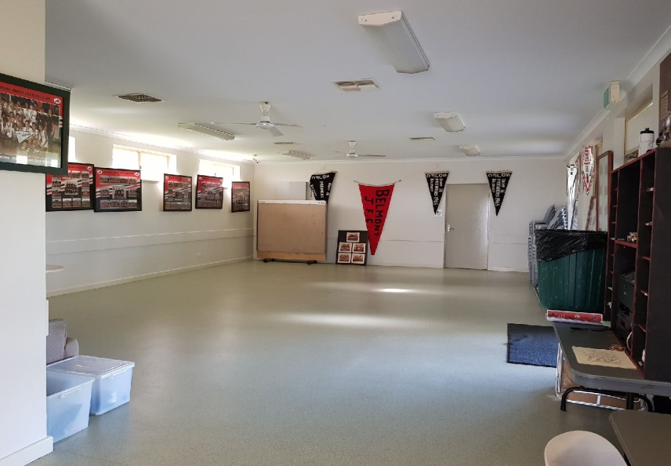

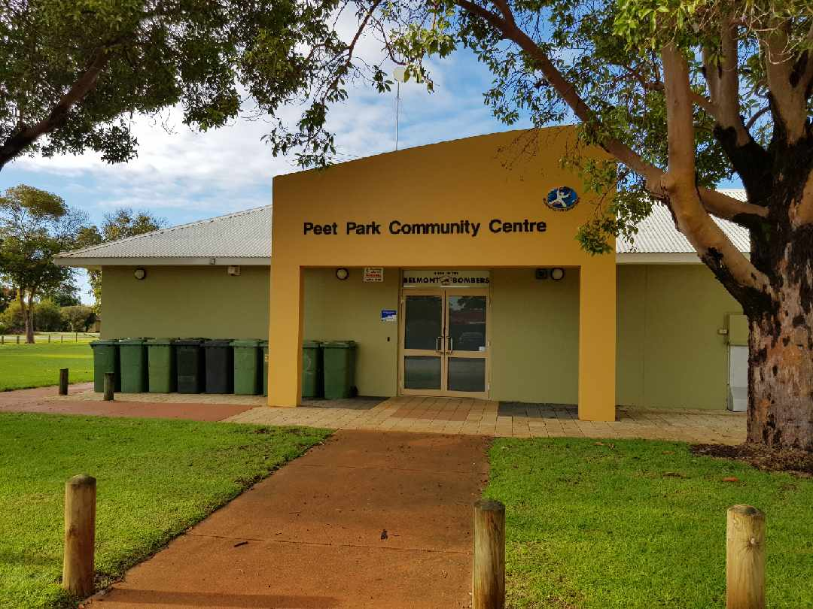

Rollup Image

Long Description

PeetPeet Park Community Centre features a large multi-purpose room and reserve. While the multi-purpose room is primarily used by sporting clubs, it also available to hire for small functions. It is adjacent to a sporting reserve that is used for cricket and football. There is a playground next to the center and practice cricket nets for everyone to use.

|  |  |  |
| --- | --- | --- |
| **GENERAL INFORMATION** | | |
| Address | 96 Sydenham Street, Kewdale | |
| Access Friendly | Yes, access friendly parking, toilets and ramps available | |
| CCTV | Yes *(cameras will not**be turned off for bookings and are not permitted to be obstructed at any time)* | |
| Parking | Yes – street parking along Sydenham Street | |
| Wi-Fi | No | |
| Equipment | Items such as TV’s, projectors, audio/visual equipment and also cleaning equipment etc. are not provided and not available for hire through the City. Hirers have to supply all their own required equipment. | |
| **MULTI-PURPOSE ROOM** | | |
| ​Size | | ​Approximately 10m x 7m (70sqm) |
| ​Max Capacity | | ​50 people (*It is an offence under Health Act 1911 to exceed the maximum capacity stipulated on the certificate of approval)* |
| ​Floor | | ​Vinyl & Carpet |
| ​Chairs | | ​50 *(measurements and photos available upon request)* |
| ​Tables | | ​8 trestle tables - 1800mm x 750mm *(photos available upon request)* |
| ​Air Conditioning | | ​Evaporative *(cooling only)* |
| ​Kitchen | | Yes, included in hire is a kitchen with a fridge/freezer, large gas stove and electric oven, auto boiler urn, microwave and servery to hall. Hirers are required to bring all their own plates/cutlery/cookware/cleaning equipment. The kitchen is to be used for warming up food purposes only. The kiosk roller door that serves outside is not available to hirers. |
| Toilets | | Yes – this room has its own facilities (located in the passageway) |
| Note | | The TV in the room is not available for use or hire. |

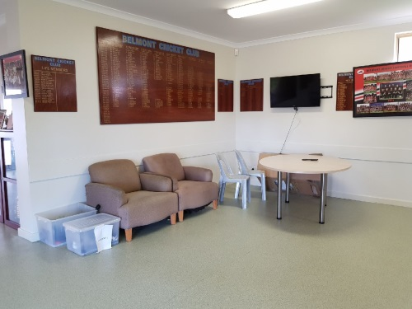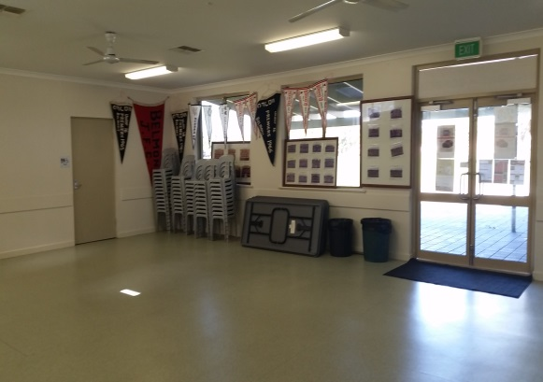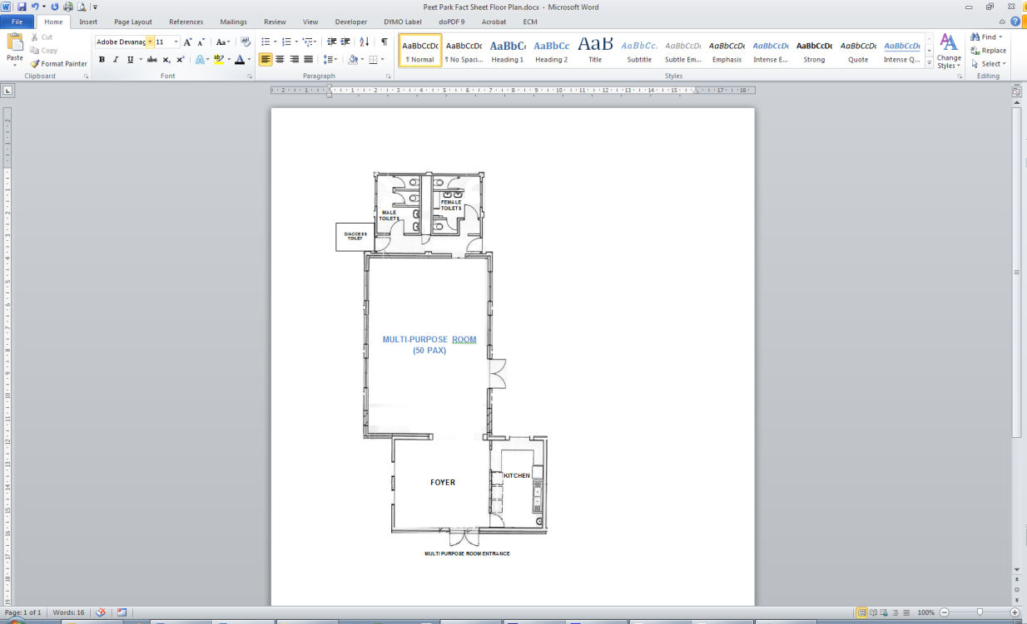

Multi-Purpose Room Kitchen

Lesser Hall Kitchen

Lesser Hall

Areas Included in Hire

Multi-Purpose Room

Kitchen

Multi-Purpose Room

|  |  |
| --- | --- |
| **RESERVE** | |
| Sport Hire *(fees applicable)* | WINTER: Football – Line markings and goals in place 1 April – 30 Sept  SUMMER: Cricket – Line markings and pitch in place 1 Oct – 30 March |
| Parking | Street parking is available along Sydenham Street. |
| Toilets | There are public toilets located next to the centre – unlocked during daylight hours. |
| Oval Lighting | There are three light towers available for hire – fees are applicable and suitable for large ball sport training only. |
| Changerooms | Yes – available for hire with reserve (toilets/showers) |
| Additional *(free to use)* | * Cricket practice nets available all year round * Playground located near Sydenham Street |

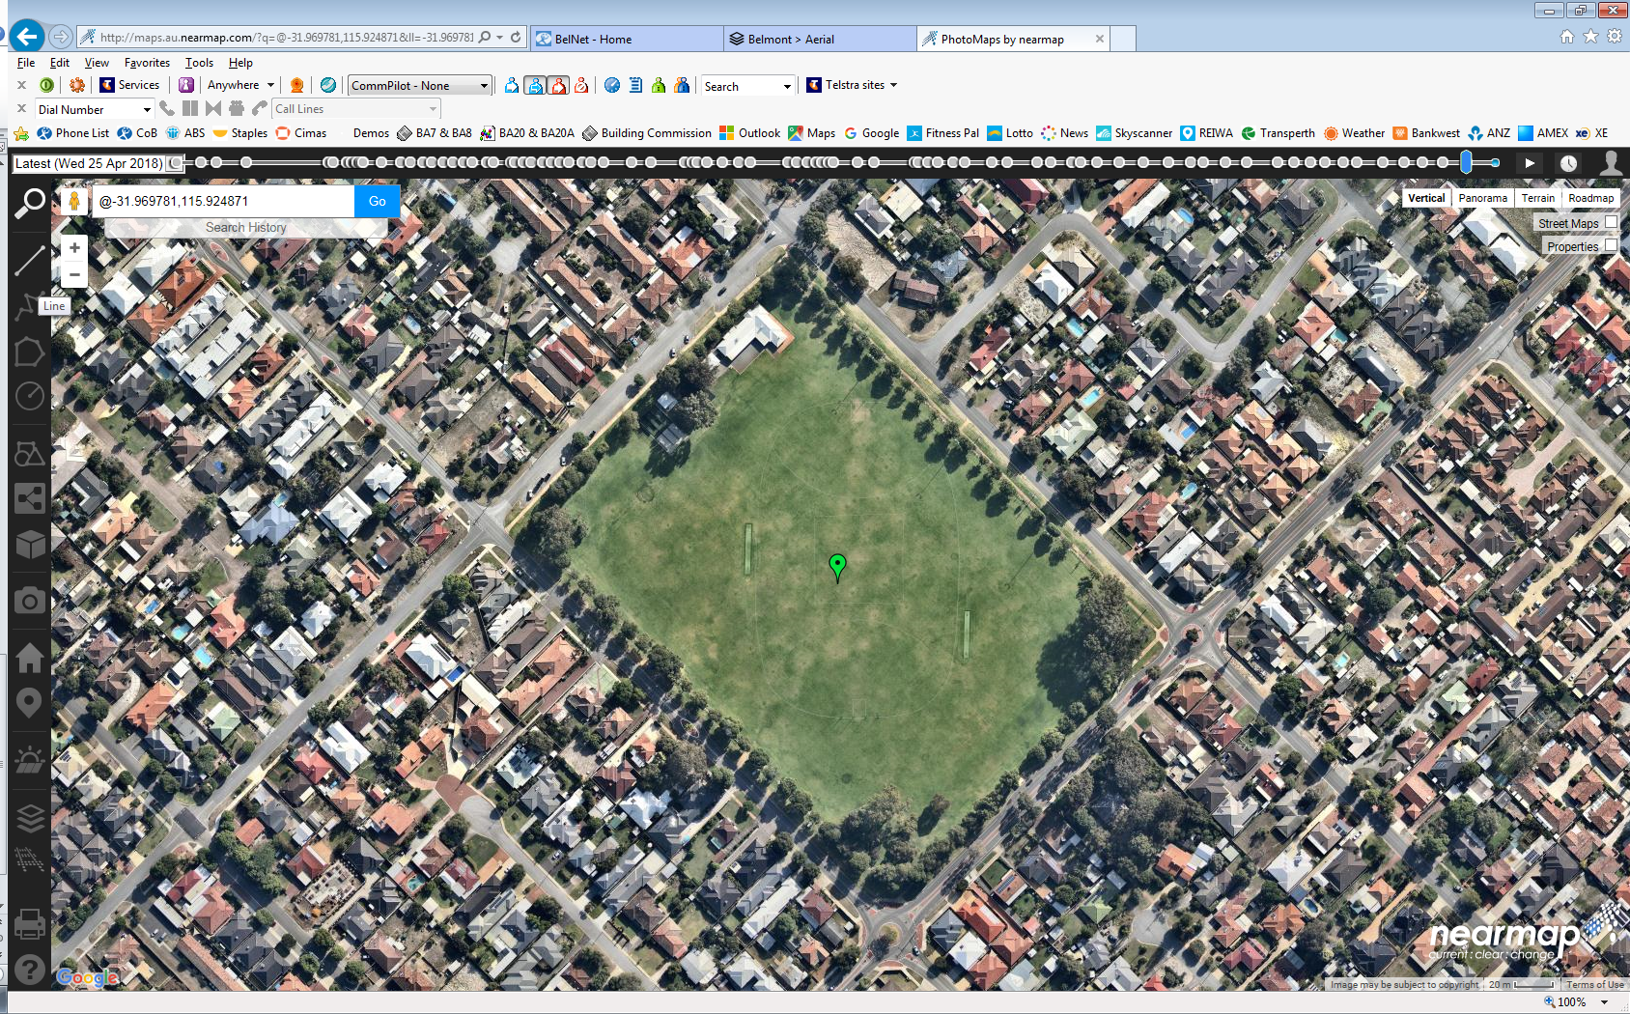

PUBLIC   
TOILETS

MULTI-PURPOSE ROOM   
*(during summer)*

CHANGE ROOMS   
*(during summer)*

**SYDENHAM ST**

RUGBY GOALS & MARKINGS   
(during winter)

**ARMADALE RD**

CRICKET PRACTICE NETS

CRICKET PITCH   
(during summer)

STREET PARKING (Sydenham Street)

FOOTBALL GOALS & MARKINGS (during winter)

CRICKET PITCH (during summer)

CRICKET PITCH (during summer)

**KOOYONG RD**

**WRIGHT ST**

For further information and availability please contact [venue.hire@belmont.wa.gov.au](mailto:venue.hire@belmont.wa.gov.au)



*City Facilities & Property – 30/07/24*