Date of Publication:19/01/2024

City of Belmont Structure
The City of Belmont is divided into four wards; each ward has two Council representatives. Local government elections are held biennially with half of the Council up for election each two years. For the first time in 2023, the Mayor was elected directly by the residents and ratepayers of the City.

City of Belmont Mayor
- Mayor Robert Rossi

City of Belmont Councillors
Central Ward
- Cr George Sekulla
- Cr Vijay
East Ward (Redcliffe, Ascot, Perth Airport)
- Cr Phil Marks
- Cr Bernie Ryan
West Ward (Rivervale, Belmont)
- Cr Deborah Sessions (Deputy Mayor)
- Cr Christopher Kulczycki
South Ward (Kewdale, Cloverdale)
- Cr Natalie Carter
- Cr Jenny Davis

The City of Belmont aims to provide for the good government of persons in the district, functioning under the Local Government Act 1995 which provides for a system of local government in Western Australia.

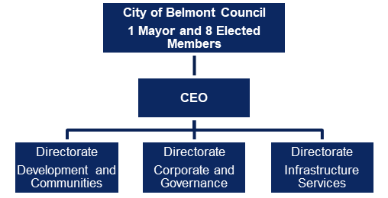

Community Involvement in Decision Making
Members of the public have a legislative right and are encouraged to participate in the decision- making process at the City of Belmont.

Agenda Briefing Forum – Submissions and Deputations
Agenda Briefing Forums are open to the public and provide an opportunity for Elected Members to be informed and seek additional information on matters prior to consideration at the next Ordinary Council Meeting. No decisions are made at the Agenda Briefing Forum.
Members of the public who are directly affected by a matter on the agenda can make a submission or deputation at the Forum. Further information is available on the City’s website www.belmont.wa.gov.au under the ‘Council and committees’ page.

Ordinary Council Meeting – Public Question Time
Ordinary Council Meetings are open to the public and are the decision-making forum of Council. Members of the public are welcome to attend and ask questions during public question time. Where a question (compliant to the rules) is raised and is unable to be answered at the meeting, it shall be ‘taken on notice’. Further information is available on the City’s website www.belmont.wa.gov.au under the ‘Council and committees’ page.

Meetings Of Council
The monthly meeting cycle of Council includes the Information Forum, Agenda Briefing Forum and Ordinary Council Meeting. Councillors are also members of Standing Committees that meet and make recommendations to Council.

2024 Meeting Dates

Agenda Briefing Forum
(6.30pm Tuesday)
20 February 2024
19 March 2024
16 April 2024
21 May 2024
18 June 2024
16 July 2024
20 August 2024
17 September 2024
15 October 2024
19 November 2024
3 December 2024

- Public submissions and deputations
- No debate or decision making
- Questions and responses on OCM agenda items
- Officer presentations
- Requests for information

Ordinary Council Meeting
(6.30pm Tuesday)
27 February 2024
26 March 2024
23 April 2024
28 May 2024
25 June 2024
23 July 2024
27 August 2024
24 September 2024
22 October 2024
26 November 2024
10 December 2024
- Public question time
- Formal decision making
- En-block voting
- Receipt of ABF information matrix
- Requests for Leave of Absence
- Confirmation of previous OCM minutes
- Receipt of Standing Committee minutes

Agendas And Minutes
Copies of publicly available agendas and minutes can be viewed on the City’s website under the ‘Agendas and minutes’ page.

Further Information
Members of the public are encouraged to contact the City with questions, feedback and concerns in relation to any of the Council services or matters at any time.
Your feedback is important as it provides the City of Belmont with the opportunity to improve services to the Community.

How To Contact The City

In Person
Office hours 8:30am to 4:45pm. Cashier closes at 4:30pm
215 Wright Street, Cloverdale WA 6105.

In Writing
Locked Bag 379, Cloverdale WA 6985.

By Telephone
Main Switchboard: 9477 7222
(Monday to Friday 8:30am to 5pm)
Belmont Community Watch
(24hr security patrol): 1300 655 011
Belmont Museum: 9477 7150
Belmont Youth Centre: 9479 5794
Graffiti Management Hotline: 9477 7226
National Relay Service TTY: 133 677
National Relay Service Voice: 1300 555 727
Ranger Services (and after hours): 9477 7224
Ruth Faulkner Library: 9477 7150
Veolia (rubbish and recycling): 9350 7182
Translating and Interpreting Service: 131 450

By Email
belmont@belmont.wa.gov.au

Via Our Website
belmont.wa.gov.au

