Decision Making Process
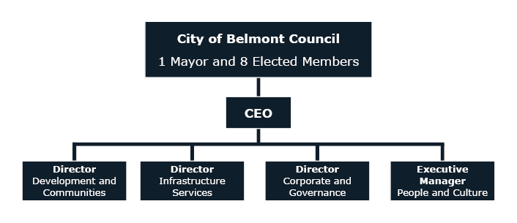

City of Belmont Structure
The City of Belmont is divided into four wards; each ward has two Council representatives. Local government elections are held every two years with half of the Councillors being up for re-election at each election. . For the first time in 2023, the Mayor was elected directly by the residents and ratepayers of the City for a term of four years.

City of Belmont Mayor
- Mayor Robert Rossi

City of Belmont Councillors
Central Ward (Belmont, Cloverdale, Kewdale, Ascot, Rivervale)
- Cr George Sekulla
- Cr Jarod Harris
East Ward (Redcliffe, Ascot, Perth Airport)
- Cr Phil Marks
- Cr Bernie Ryan
West Ward (Rivervale, Belmont)
- Cr Deborah Sessions (Deputy Mayor)
- Cr Christopher Kulczycki
South Ward (Kewdale, Cloverdale)
- Cr Janet Powell
- Cr Jenny Davis

The City of Belmont aims to provide for the good government of persons in the district, functioning under the Local Government Act 1995 (WA) (the Act) which provides for a system of local government in Western Australia.

Community Involvement in Decision Making
Members of the public are encouraged to participate in the decision-making process at the City of Belmont.

Agenda Briefing Forum – Submissions and Deputations
Agenda Briefing Forums are open to the public and provide an opportunity for Elected Members to be informed and seek additional information on matters prior to consideration at the next Ordinary Council Meeting. No decisions are made at the Agenda Briefing Forum.
Members of the public who are directly affected by a matter on the agenda can make a submission or deputation at the Forum. Find out more on the City’s website.

Ordinary Council Meeting – Public Question Time
As per the Act, Ordinary Council Meetings are open to the public and the decision-making forum of Council. Members of the public can ask questions during public question time, subject to the rules of question time. Where a question is unable to be answered at the meeting, it shall be ‘taken on notice’. Find out more on the City’s website.
Meetings Of Council

Agenda Briefing
Forum
Third Tuesday of each meeting month (6.30pm)
Open to Public
(Chaired by Mayor)
Purpose:
• Public submissions and deputations
• No debate or decision making
• Questions and responses on OCM agenda items
• Officer presentations
• Requests for information
Ordinary Council Meeting
Fourth Tuesday of each meeting month (6.30pm)
Open to Public
(Chaired by Mayor)
Interests to be declared
Purpose:
- Public question time
- Formal decision making
- En-block voting
- Receipt of ABF information matrix
- Requests for Leave of Absence
- Confirmation of previous OCM minutes
- Receipt of Standing Committee Minutes
The monthly meeting cycle of Council (from February to December) includes the Information Forum, Agenda Briefing Forum and Ordinary Council Meeting. Councillors are also members of Standing Committees that meet and make recommendations to Council.

2025 Council Meeting Dates
Agenda Briefing Forum
(6.30pm Tuesday)
18 February 2025
18 March 2025
8 April 2025
20 May 2025
17 June 2025
15 July 2025
19 August 2025
16 September 2025
14 October 2025
18 November 2025
9 December 2025

Ordinary Council Meeting
(6.30pm Tuesday)
25 February 2025
25 March 2025
15 April 2025
27 May 2025
24 June 2025
22 July 2025
26 August 2025
23 September 2025
21 October 2025
25 November 2025
16 December 2025

Agendas And Minutes
Copies of publicly available agendas and minutes are available on the City’s website.

Further Information
Members of the public are encouraged to contact the City with questions, feedback and concerns in relation to any of the Council services or matters at any time.
Your feedback is important as it provides the City of Belmont with the opportunity to improve services to the Community. Please send your feedback to Belmont.belmont@belmont.wa.gov.au

How To Contact The City

In Person
Office hours 8:30am to 4:45pm.
Cashier closes at 4:30pm
215 Wright Street, Cloverdale WA 6105.

In Writing
Locked Bag 379, Cloverdale WA 6985.

By Telephone
Main Switchboard: 9477 7222
(Monday to Friday 8:30am to 5pm)
Belmont Community Watch
(24hr security patrol): 1300 655 011
Belmont Museum: 9477 7150
Belmont Youth Centre: 9479 5794
Graffiti Management Hotline: 9477 7226

National Relay Service TTY: 133 677
National Relay Service Voice: 1300 555 727
Ranger Services
(and after hours): 9477 7224
Ruth Faulkner Library: 9477 7150
Veolia (rubbish and recycling): 9350 7182
Translating and Interpreting
Service: 131 450

By Email
belmont@belmont.wa.gov.au

Via Our Website
belmont.wa.gov.au

