CITY OF BELMONT

**Facilities for Hire**

**Middleton Park Community Centre & Reserve**

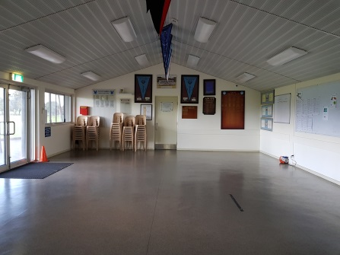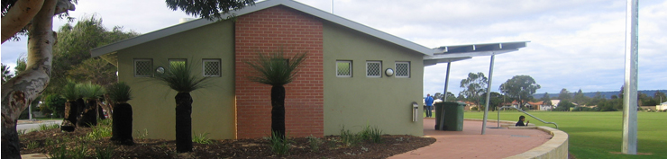

Rollup Image

Long Description

PeetMMiddMiddleton Park Community Centre features a large multi-purpose room and reserve. While the multi-purpose room is primarily used by sporting clubs on weekends, it is available to hire for small functions and meetings during the week. It is adjacent to a sporting reserve that is used for cricket and football.

|  |  |  |
| --- | --- | --- |
| **GENERAL INFORMATION** | | |
| Address | 13 Middleton Street, Cloverdale (parking on Garvey Street) | |
| Access Friendly | Yes, access friendly parking, ramps and toilets available | |
| CCTV | Yes *(cameras will not**be turned off for bookings and are not permitted to be obstructed at any time)* | |
| Parking | Yes – street parking along Garvey Street and verge parking along Epsom Avenue | |
| Wi-Fi | No | |
| Equipment | Items such as TV’s, projectors, audio/visual equipment and also cleaning equipment etc. are not provided and not available for hire through the City. Hirers have to supply all their own required equipment. | |
| **MULTI-PURPOSE ROOM** | | |
| ​Size | | ​Approximately 10m x 7.5m (75sqm) |
| ​Max Capacity | | ​50 people (*It is an offence under Health Act 1911 to exceed the maximum capacity stipulated on the certificate of approval)* |
| ​Floor | | ​Vinyl |
| ​Chairs | | ​50 *(measurements and photos available upon request)* |
| ​Tables | | ​10 trestle tables - 1800mm x 750mm *(photos available upon request)* |
| ​Air Conditioning | | Evaporative *(cooling only)* |
| ​Kitchen | | Yes, included in hire is a small kitchen with a fridge/freezer, stove and oven, auto boiler urn, microwave and servery to room. Hirers are required to bring all their own plates/cutlery/cookware/cleaning equipment. The kitchen is to be used for warming up food purposes only. The kiosk roller door that serves outside is not available to hirers. |
| Toilets | | Yes – this room has its own facilities (located in the passageway) |

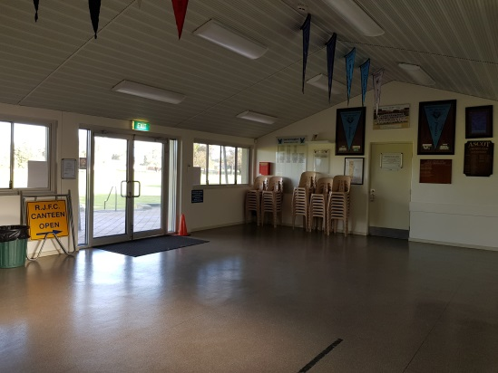

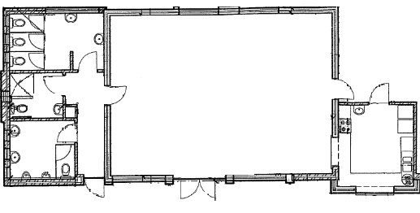

Lesser Hall Kitchen

Lesser Hall

**TOILET  
FACILITIES**

**MULTI-PURPOSE ROOM   
(50 PAX)**

Multi-Purpose Room Kitchen

**KITCHEN**

Areas Included in Hire

Multi-Purpose Room

Kitchen

|  |  |
| --- | --- |
| **RESERVE** | |
| Sport Hire *(fees applicable)* | WINTER: Football – Line markings and goals in place 1 April – 30 Sept  SUMMER: Cricket – two pitches and line marking in place 1 Oct – 30 March |
| Parking | Parking is available along Garvey Street and Epsom Avenue |
| Toilets | There are no public toilets available – toilets are available for use with hire of the reserve |
| Oval Lighting | There are two towers on this reserve for hire – fees are applicable and suitable for large ball sport only. |
| Changerooms | Yes – available for hire with reserve (toilets/showers). |
| Additional *(free to use)* | There are cricket practice nets available all year round. There is a small playground near the corner of Middleton Street & Sutherland Way. |

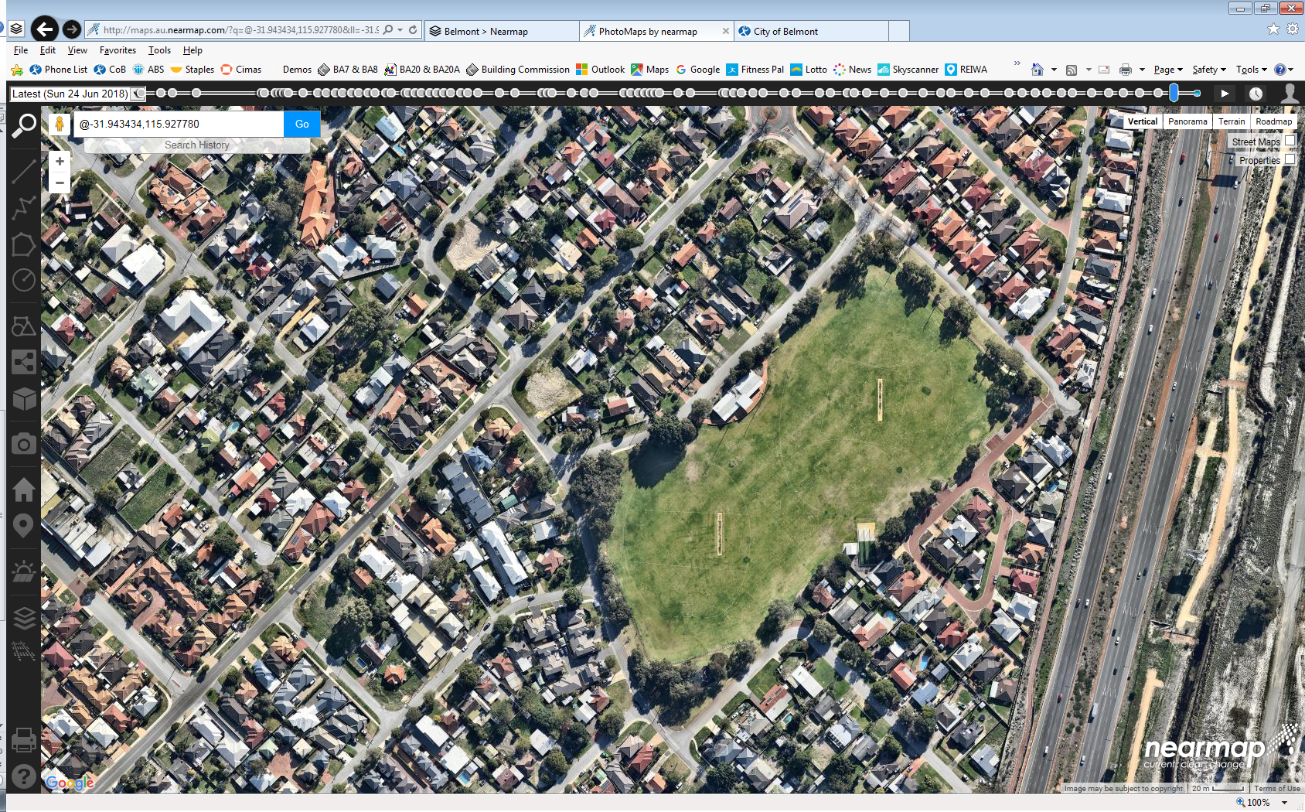

**GARVEY STREET**

CRICKET PITCH & MARKINGS   
(during summer)

CHANGE ROOMS   
*(during summer)*

MULTI-PURPOSE ROOM

FOOTY GOALS & MARKINGS   
(during winter)

CRICKET PITCH & MARKINGS   
(during summer)

FOOTY GOALS & MARKINGS   
(during winter)

**BELGRAVIA ST**

PRACTICE CRICKET NETS

PLAYGROUND   
*(during summer)*

LARGE CARPARK  
(via Lowes Street)

For further information and availability please contact [venue.hire@belmont.wa.gov.au](mailto:venue.hire@belmont.wa.gov.au)



Building Services

Date: 5/9/2018