

To All Councillors

CC ELT
Manager Planning Services
Coordinator Planning
Senior Planning Officer (SPO1)

From Director Development and Communities

Subject Development Application Advertising at 3 Hawksburn Road, Rivervale – 14 Storey Mixed Use Development (comprising 123 Apartments and 4 Ground Floor Commercial Tenancies comprising of Café, Consulting Rooms, Shop and Health Studio)

Date 25 February 2021

Dear Councillors

I wish to advise that the abovementioned Joint Development Assessment Panel application has been referred to landowners and occupiers for comment. The consultation period commenced Tuesday, 16 February 2021 and closes Thursday, 4 March 2021. I apologise for the delay in informing you.

Specifically, the development application has been referred to the following owners and occupiers:

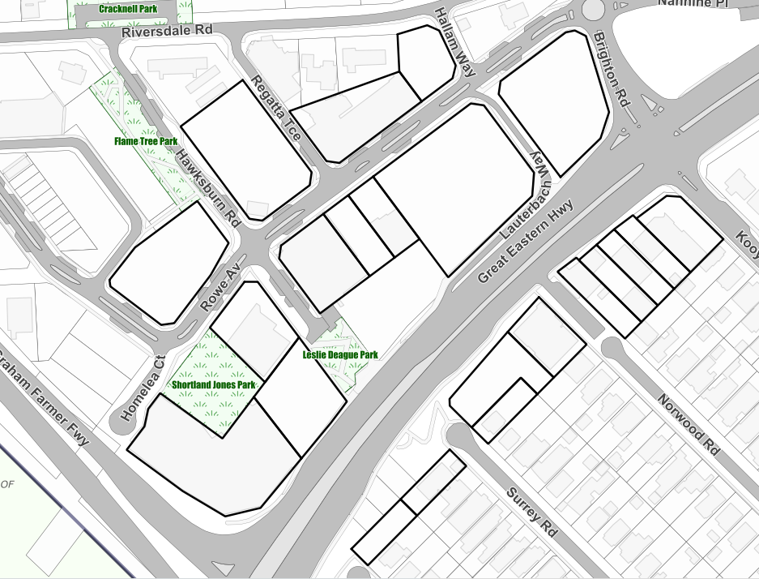
Subject Site
X
X
X
X
X
X
X
X
X
X
X
X
X
X
X
X
X
X
X
X
X
X
Figure 1: Referral Properties Marked X

The application proposes a 14 storey building, including 123 apartments, a communal open space area for residents on the roof, 4 commercial ground floor tenancies to accommodate a Café, Consulting Room, Shop and Health Studio.

In pursuing design excellence for development in the City of Belmont, the applicant’s proposal has been reviewed on two occasions by the City’s Design Review Panel (DRP). The proposal achieved 8 out of 10 ‘green’ scores and the two remaining principles scored ‘orange’. The DRP are satisfied that the proponent has met most of the design principles and the applicant is addressing the outstanding matters which relate to Sustainability and Landscape Design.

Notwithstanding the DRP’s review of the proposal, the applicant must also address the requirements of the planning framework. At present, the proposal does not meet various requirements under the planning framework. These are:

- Plot Ratio – 4.21 in lieu of 1.0. The previous development approval for the site had a plot ratio of 3.77.

- Height – 14 storeys (plus a communal roof space) in lieu of a maximum of nine storeys. Height variations that exceed the prescribed maximum have previously been supported in this area. Examples of this include the Aloft Hotel, 23 Rowe Avenue and 3 Homelea Court.

- Building Separation – concerns for the separation distances between the proposed development and 5 Hawksburn Road.

- Visual Privacy – concerns regarding the setback of the balconies along the
north-western side of the building, adjacent to 5 Hawksburn Road.

Once advertising is completed, the merit of the proposal will be considered against the planning framework and matters raised in submissions during the advertising period. Officers are required to prepare a Responsibility Authority Report (RAR) by 25 March 2021 for the Metro Inner-South Joint Development Assessment Panel to determine the application. I will provide a further update to Councillors once the planning assessment has been completed and the RAR has been prepared.

Should you have any enquiries in relation to this application please contact the Manager Planning Services, Wilmot Loh by email: wilmot.loh@belmont.wa.gov.au or on 9477 7275.

Yours sincerely
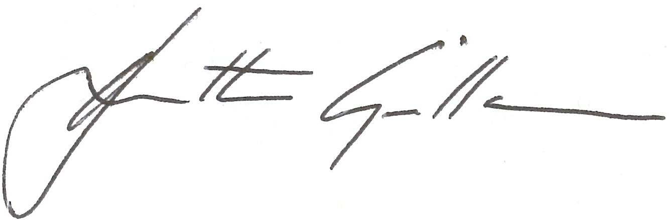

JULIETTE GILLAN
DIRECTOR DEVELOPMENT AND COMMUNITIES

Attch

Attachment 1

