CITY OF BELMONT

**Facilities for Hire**

**Youth & Family Services - Training Room**

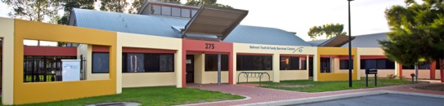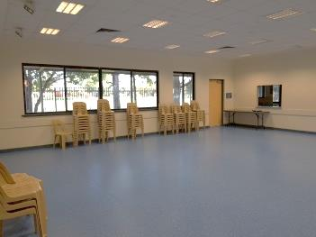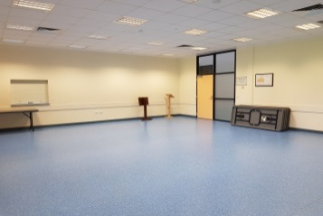

The Youth & Family Services Building is conveniently located on Abernethy Road and features a training room that is suitable for meetings, training sessions and small seminars.

|  |  |
| --- | --- |
| **GENERAL INFORMATION** | |
| Address | 275 Abernethy Road, Cloverdale |
| Access Friendly | Yes, access friendly parking, toilets and ramps available |
| CCTV | Yes *(cameras will not**be turned off for bookings and are not permitted to be obstructed at any time)* |
| Parking | Yes – there is a large carpark out the front of the building |
| Wi-Fi | No |
| Equipment | Items such as TV’s, projectors, audio/visual equipment and also cleaning equipment etc. are not provided and not available for hire through the City. Hirers have to supply all their own required equipment. There is a small whiteboard available for use but markers are not provided. |
| **TRAINING ROOM** | |
| ​Size | ​Approximately 8m x 10m (80sqm) |
| ​Max Capacity | ​60 people (*It is an offence under Health Act 1911 to exceed the maximum capacity stipulated on the certificate of approval)* |
| ​Floor | ​Vinyl |
| ​Chairs | ​60 *(measurements and photos available upon request)* |
| ​Tables | ​10 trestle tables - 1800mm x 750mm *(photos available upon request)* |
| ​Air Conditioning | ​Ducted *(heating & cooling)* |
| ​Kitchen | Yes, included in hire is a shared kitchen facilities that have a fridge/freezer, small stove and oven, auto boiler urn, microwave and servery to the training room. Hirers are required to bring all their own plates/cutlery/cookware/cleaning equipment. The kitchen is to be used for warming up food purposes only. |
| Toilets | Yes – shared facilities located in the passageway |
| Note | The room features an enclosed outdoor area (shared access via the kitchen) |

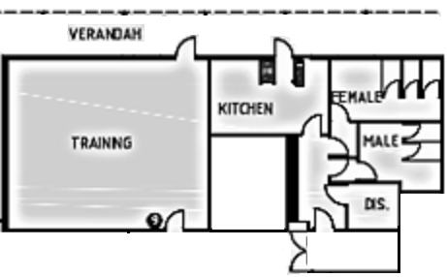

**For further information and availability please contact** [**venue.hire@belmont.wa.gov.au**](mailto:venue.hire@belmont.wa.gov.au)



Areas Included in Hire  
*(kitchen & toilets shared facilities)*